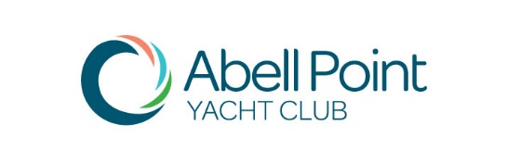

Mail: PO Box 912 Cannonvale QLD 4802
Email: abellpointyc@gmail.com
ANNUAL GENERAL MEETING

Sunday 7th October 2018 at 2.00pm
Ocean Club on the Marina
O & P Gate, Abell Point Marina

PROXY FORM

To the Secretary, Abell Point Yacht Club (APYC):

I/we ………………………………………………………………………………………... (name/s)
Of (Residential Address)
…………………………………………………………………………………………..…………
Being financial member/s of the APYC for the financial year 2018/2019 hereby appoint (circle one):
- Commodore
or
- …………………………………………………… (financial member’s name)

As my/our proxy to vote on my/our behalf at the Annual General Meeting on Sunday 7th October 2018 and any adjournment thereafter.

Signature/s ………………………………………………………

………………………………………………………

Date …………………………………..

Form to be returned by: Thursday 4th October 2018
Return Form Via Email To: abellpointyc@gmail.com

