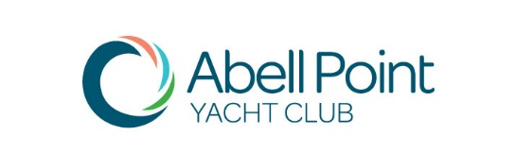
NOTICE OF ANNUAL GENERAL MEETING
Sunday 7th October 2018 at 2.00pm
Ocean Club on the Marina
O & P Gate, Abell Point Marina

The Management Committee of the Abell Point Yacht Club wishes to advise that the ANNUAL GENERAL MEETING for 2018/2019 will be held at Ocean Club, O&P Gate, Abell Point Marina on Sunday 7th October 2018 at 2.00pm. Following the AGM, you are invited to stay for a social get together.
If you are unable to attend please complete the Proxy Form attached. Please be aware that you must be a financial member of the Club to vote at the AGM and to nominate for positions on the Management Committee.

AGENDA
- Apologies / Proxies
- Minutes of the 2017 AGM Acceptance
- Management Committee Reports
- Election of Auditor for 2018/2019
- Election of Management Committee for 2018/2019
- Close of Meeting

Nominations for Management Committee
Under the Club Rules, nominations for Management Committee are required to be submitted in writing at least 14 days prior (no later than 22.09.2018) to the AGM. If you are unable to attend the AGM, your Proxy Form is also required to be returned at this time. If you would like to nominate for the Committee or need to complete the Proxy Form, please ensure this is submitted before Thursday 4th October 2018.

Charlie Preen
Commodore Abell Point Yacht Club

