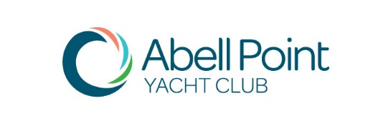

MANAGEMENT COMMITTEE NOMINATION
ANNUAL GENERAL MEETING
Sunday 7th October 2018 at 2.00pm
Ocean Club on the Marina
O & P Gate, Abell Point Marina

I, ………..…………………………………….… Member No ……………………..………………

Email. ……………………………………….……..….. Contact Phone…………….…………………

hereby nominate for the following position/s on the Management Committee (nominations may be for more than one position):

Position | Please Tick | Position | Please Tick
Commodore |  | Treasurer
Vice Commodore |  | Committee Member  (6 Positions available)
Secretary

Nominee’s Signature ………………………………………………Date ………………………….…

Proposer:
Name …………..……………………………… Member No. ……………………….
Signature ………….………………………………….
Seconder:
Name …………………………….……….. Member No. ………………………
Signature ………………………………………….
Under the Club Rules, nominations for Management Committee are required to be submitted in writing at least 14 days prior (no later than 22.09.2018) to the AGM.
Please Email Completed Nominations Forms To: abellpointyc@gmail.com

